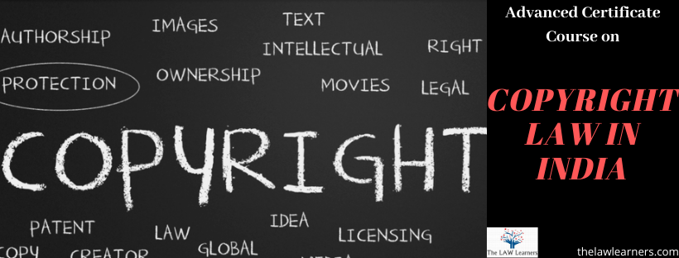

ASSIGNMENT
Name : -
Email ID :-
Contact no. –

ONE LINER ANSWERS 2 Marks each
- What was the first Copyright Law that India enacted after Independence?

- The Public Notice of Relinquishment remains for a minimum of _________________ years on the Official Records.

- Is Register the Prima Facie evidence of Copyright?

- Is it mandatory to register ones Copyright?

- Is India Signatory to the major Convention dealing with Intellectual Properties? Name the Convention being talked about.

SUBJECTIVE QUESTIONS [WITHIN 100 WORDS EACH] 5 MARKS
1. Explain in brief, the procedure for registration of a Copyright?

2. What happens if the author does not register his/ her copyright?

3. Explain in brief, the Jurisdiction of Various Courts in dealing with matters pertaining to
copyrights.

4. Explain the procedure and remedies of Appeal(s) if any, which lie against the orders of
lower courts in cases of infringement of Copyright.

ANALYTICAL QUESTIONS (WITHIN 200 WORDS EACH) 10 Marks
- Even in today’s era, common people are reluctant to enter into the legalities of intellectual properties in their day to day dealings. What can be done to educate the mass about the importance of Intellectual Properties?

2. Explain in brief, the measures that can be adopted for prevention of Large ScaleCopyright violations in today’s era of Digitalization.

